
LSRAA News _{Spring 2010}

Inside This Issue
Word from the Board President Page 1
Meet the Board Page 2
Where Your Money Goes Page 2
Back to Algebra Page 3
LSR Class XXVII Enrollment Page 3
LSR Alumni On The Move Page 3
Consulting with Kerry Rego Page 4

A Word from the
Board President
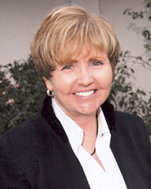
It’s BBQ time! I can hardly wait to see my good friends and our warm Sonoma County weather. Join us for tons of fun, delicious food and fine wines at the BBQ on June 16th from 5-8 p.m. at Richard’s Grove & Saralee’s Vineyard. Lisa Hemenway prepared an awesome menu of pulled pork, chicken, BBQ oysters, and salads. Another treat is that John Ash is providing the dessert. So connect with leaders in the community at our annual summer kick-off celebration and fundraiser for LSR and TLT. I’ve included the flyer in the Newsletter—just fill in the info and send it in with your check.
If you would like, there is new way to pay and it’s way easy. Now you can pay online for the BBQ or your membership. Just go to www.lsraa.org. I want to thank Anne Marie Przyblyski for chairing the BBQ Committee and the LSRAA Board of Directors for hosting this fun event for you. Sponsorships are now available and range in price from as little as $25, which you can pay online.
We haven’t forgotten about all of the golfers or wannabe golfers like me. We are spreading out our events and are hosting our annual golf tournament on September 24th. Details will be forthcoming.
On Thursday, May 20 at 5:15, we are having a social at Rendezvous Bistro on 614 4th Street. I hope you will join us for a no-host bar: have a drink, shmooze, and enjoy the occasion.
Thank you again for your continued support and for allowing me the opportunity to serve LSRAA.

LSRAA Board President
Dr. Mary Bates, CEO
Boys & Girls Clubs of Greater Santa Rosa



Management is doing things right;
leadership is doing the right things.

Peter F. Drucke



Meet the 2009-2010

LSRAA Board of Directors
LSRAA BOARD

President, Mary Bates, Class 21
c. 484-2068 h. 526-9850
srbandg@sbcglobal.net
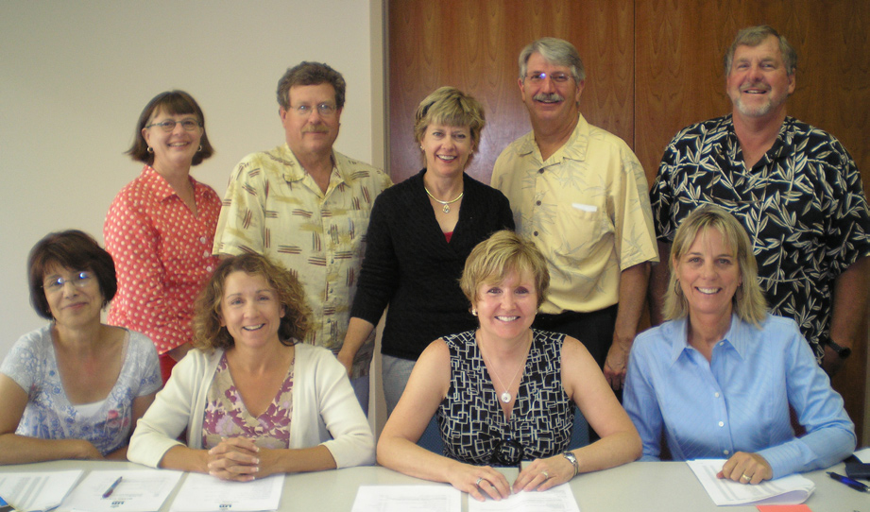
Treasurer, Lisa Hemenway, Class 11
c. 290-9337 h. 571-1355
lisahem@sonic.net
Secretary, Joan Demitz, Class 11
523-0199
jdemitz@sonic.net
Kris Anderson, Class 9
w. 521-3434 x 23 838-2760
krisanderson@manos.us
Henry Kaku, Class 13
c. 486-4576 w. 525-5300 x 6110
Standing L-R: Sharie Sbrazza, Chris Smith, Kris Anderson, Chris Rosell, Bob Parker
Front Row: Secretary, Joan Demitz, Pres., Mary Bates,
Treasurer, Lisa Hemenway
Not Pictured: Jenifer Levini, Henry Kaku, David O’Rourke, Eugene Patterson, Anne Marie Przyblyski, Kerry Rego

hkaku@sbcglobal.net
Jenifer Levini, Class 16
w. 544-9882
jenifer@webpresenceinc.com
David O’Rourke, Class 25

h. 415-320-2579
Dave@wcfsinc.com
Bob Parker, Class 11
c. 477-0145 h. 546-6764
robparker@att.net
A portion of your dues, fees for events and your contributions are donated to LSR & TLT, which will help make the classes more diverse. The more diverse the participants, the richer the experience is for the students. Some prospective students tell us that the cost of the tuition prohibits them from joining the class. Please help these students and help Leadership Santa Rosa provide services to students from wider ranges of age, ethnicity, and income level. Give online at www.lsraa.org or send donations to: LSRAA, P.O. Box 742, Santa Rosa, CA 95402
A huge thank you to Bob Parker, Board member, and the many sponsors for raising donations to award $2,200 toLSR and $2,200 to TLT.

Where Your
Money Goes
Eugene Patterson, Class 23
w. 524-3397
pattersone@exchangebank.com
Anne Marie Przyblyski, Class 21
829-3059
qamq@sbcglobal.net
Kerry Rego, Class 26
548-9823
Kerry@KerryRegoConsulting.com
Chris Rosell, Class 11
568-1855
chrisrosell@bankofmarin.com
Sharie Sbrazza, Class 22
c. 322-7200 w. 522-0340 h. 578-5750
andiamotravel@hotmail.com
Chris Smith, Class 11
477-6489
Chris.smith@pressdemcrat.com


Page 2 of 4

Back to
Algebra

LSR Alumni
On The Move




Scott Swanson, Class X, is beaming even brighter than usual. The former Santa Rosa Deputy Police Chief couldn’t be prouder that his son, Joe, a 2002 Maria Carrillo High grad alum and Tomorrow’s Leaders Today grad who’s been a police officer in Bozeman, Mont., for barely two years, has been named that city’s Officer of the Year.
Wes Winter, Class XXI, is in Ukiah, immersing himself in his position as executive director of North Coast Opportunities, Inc., a community services organization serving seven counties. Wes previously worked for Oakmont Senior Living, promoting the proposed Fountaingrove Lodge, which recently was approved by the Santa Rosa City Council. Prior to that he served as Executive Director of the Volunteer Center of Sonoma County.
John Bribiescas, Class IX, is rallying the community to help Schools Plus, which he co-founded, assure that spring sports will not be cut from Santa Rosa’s high schools and, hopefully, not from the middle schools either. John is the retired head of the English Department at Santa Rosa High and is passionate about the potential of Schools Plus.
Janet Rogers, Class XIV, the former coordinator of LSR, now has new responsibilities at the Chamber of Commerce. Janet is focusing more on membership and retention at the chamber. She had relinquished her LSR duties to Kelly Bass.
Glenda Humiston, Class X, continues to ascend to positions of greater responsibility within the U.S. Department of Agriculture. Glenda is currently the USDA’s Rural Development state director.
Chris Rosell, Class XI, is working now as a vice president for Bank of Marin and the bank’s private banker for Sonoma County. Chris was previously with Sonoma Bank.
Marc Van Riper, Class XXII, has expressed his heartfelt gratitude to the LSR friends who supported him and his entire through the cancer ordeal that in February claimed his astounding wife and the love of his life, Kathy.
She was 40 and lived a blessed life in defiance of the disease that menaced her for a decade. LSR was represented well at the celebration of Kathy’s life that drew nearly 1,200 people

If you’re considering recipients for your charitable gifts this year, you might do no better than the Mike Hauser Algebra Academy.
This cooperative effort provides essential algebra and real-world math instruction to local students who are learning English at the same time they’re struggling to understand mathematics.
The academy is a legacy of Hauser, the late Chamber of Commerce president who recognized that learning algebra is a key obstacle to English-language learners who aspire to graduate from high school and launch successful careers.
Hauser also was an important supporter of LSR.
If you’d care to make a contribution to the academy, send a check payable to New Vision Santa Rosa Foundation, 637 First St., Santa Rosa, CA, 95401.

LSR Class XXVII
Enrollment

Quick. Who’s the person you know (a friend, colleague, fellow Little League parent, drinking buddy) who’s just perfect for LSR and should be in the next class?
Whoever this somebody is, give him or her a shout. The deadline for applying for LSR Class XXVII is Friday, May 7, at 5 p.m.
Applications are available at the Chamber of Commerce office or online at www.santarosachamber.com.
Tell a friend.

Page 3 of 4

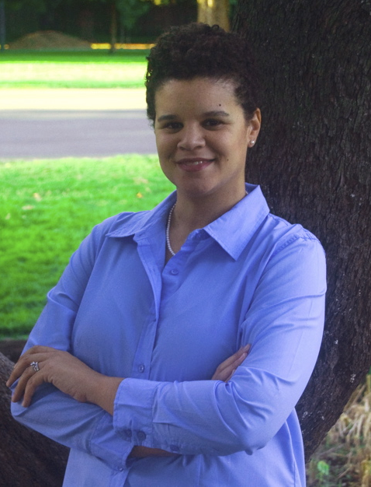






As a kid in Santa Rosa, Kerry Rego, the newest member of the board of the Leadership Santa Rosa Alumni Association, was always flying off. Her parents – father Kevin Quirk, late mother Daphne Quirk and stepmother Sue Sarmir – all were pilots. Her grandpa, Barry Quirk, too.
“Pretty much every weekend I was in a plane of some sort,” recalled Kerry, a 1995 graduate of Santa Rosa High, member of the current LSR class and ambassador for LSR’s parent organization, the Santa Rosa Chamber of Commerce.
Did she love absolutely adore spending as much time soaring above the clouds as most of her friends spent riding in station wagons? She did not. Fact is she found all that flying pretty boring.
What she loved was acting in school theatrical productions, dancing, singing, modeling. From 1997 until 2003 she was a professional actor and model. She appeared mostly in infomercials and industrial and point-of-sale films that promoted a variety of products to dealers. It was fun, ever–changing work.
“I liked the fact that every single day I didn’t know what I would be doing,” Kerry said. “One day I was paid to jump on a trampoline in a
business suit and the next day I was paid to ride a bicycle down a hill.”
While working in front of the camera she also studied office technology and efficiency. In 2006 she made a leap and opened Kerry Rego Consulting. She offers a variety of tech and organization services to businesspeople, many of whom, she said, weren’t much interested in communication technology “until social media exploded.”
“I strive to be an agent of change,” she declares on her Website, www.kerryregoconsulting.com. “I help individuals, businesses, and organizations learn, grow, and solve their problems using technology and organization.”
Kerry is also a professional speaker who addresses business audiences on topics and workplace issues such as overcoming techno-phobia, social media in business and education, female and youth empowerment, and networking tips.
And recently she and her entertainment manager agreed to resubmit her for acting work. “Nothing major,” she said. Her photos will go out to casting agents “and occasionally I’ll be auditioning in San Francisco for acting and modeling work.”
Why did she apply to LSR? “Education is really what drove me there,” she said. That and a desire to meet more interesting, community-engaged people. She said she hasn’t been at all disappointed.
Though not yet an alumnae, she accepted an invitation by LSRAA President Mary Bates to join the alumni association board. She’s quickly immersed herself in the organization’s efforts to keep the community of LSR graduates informed and cohesive.
One of her goals as a board member, she said, is to foster greater awareness through Santa Rosa and beyond “of who we are and what we do.” Her fellow LSRAA board members are delighted to have her aboard.
Kerry’s husband, fellow Santa Rosa native Daniel Rego, is the owner of All-Pro Painting. Their daughter, Joy, is 4.
Consulting with
Kerry Rego

Page 4 of 4

